**Class 7 - Content: Requests and offers**

I – Objective: Making requests

Warm up - Let it be – The Beatles - <https://www.youtube.com/watch?v=rVTt32YFbcs>

I – Problem 1: Prepare a dialogue based on the following situation (adapted from <https://freeenglishlessonplans.com/tag/making-requests/>): (2,0 pontos)

Student A: You are a salesperson in a company. You are very stressed, and you need a rest, you have decided that you want to take a sabbatical to go and to do a volunteer work for a year. You need to speak to the boss. You are very hard-working, and the company is doing very well because of your hard work.

Student B: You are the boss of a company. One of your employees comes to ask you something. You have heard a rumour that this employee wants to take a sabbatical. He/she is your best salesperson and the company really needs him/her. You can offer him/her a pay rise, a promotion and a 1-month holiday.

To help you to do the activity, you can follow these steps or another one from your choice:

1- Watching a video: watch this video to improve vocabulary and learn expressions about requests and take notes if it is necessary.

<https://www.youtube.com/watch?v=RHVgeNFfzn4>

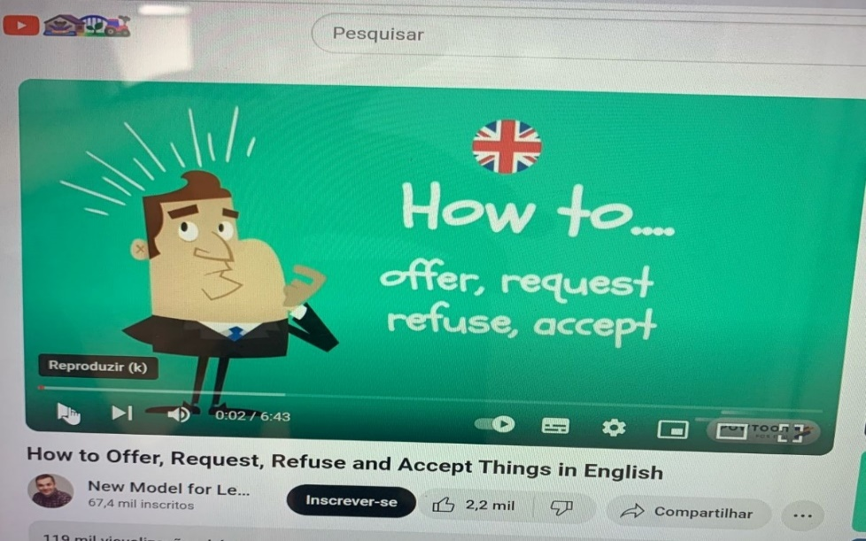

2- Reading and vocabulary: read these ways to make and to respond requests to improve vocabulary.

1-Making request

|  |  |
| --- | --- |
| Request on Twitter: "Scared about making mistakes when sending ... | Can you…?  Can you help me with this exercise? |
| Could you…?  Could you help me with this exercise? |
| Shall you…?  Shall you help me with this exercise? |
| Would you mind…?  Would you mind helping me with this exercise? |
| I was wondering if you could…  I was wondering if you could help me with this exercise. |
| I would (I’d) appreciate if you could…  I’d appreciate if you could help me with this exercise. |
| Is it OK if…?  Is it OK if you help me with this exercise? |

2- Accepting request

|  |  |
| --- | --- |
| Hand, Thumb, Sign, Ok, Yes, Positive | All right / Alright |
| Sure! |
| Here you are |
| Yes, of course |
| I’d be happy to |
| My pleasure |
| Sure! I’d be glad to |
| No problem |
| Certainly |

3-Refusing request

|  |  |
| --- | --- |
| No, Reject, To Forbid, Denial, Refusal | Sorry |
| No, I’m sorry, I can’t |
| I would (I’d) like to but |
| I’m afraid I |
| It sounds great, but |
| I’d love to, but |
| I wish I could but |

3 - Vocabulary exercise:

3.1 – Match the questions and the answers:

A) Would you like any coffee? ( ) No, thanks. Could we have the bill,

please.

B) I’ll carry your bag if you like ( ) I’m afraid the line’s engaged. Do you want

to hold?

C) Can you tell me the phone ( ) Hang on. I’ll look it up.

number?

D) Two coffees, please. ( ) Not at all. I’ll do it now.

E) Would you mind checking ( ) Certainly. Would you like milk and sugar?

these?

F) Could I speak to Caroline, ( ) Thanks a lot. Could you take it to my room?

please?

( from <https://elt.oup.com/student/headway/int/vocabulary/unit04/hwy_int_unit04_4?cc=br&selLanguage=pt>)

**Class 8 - Content: Requests and offers**

I – Objective: Making requests

# Warm up: Nirvana - Come as You Are - <https://www.youtube.com/watch?v=zfJjcfAPCxo>

4- Dialogues: Read the dialogue to practice request and to improve pronunciation.

**Conversation 1:**

Paul needs to ask his boss for permission to leave work early the next day:

Paul:   Mr Clark.

Mr Clark:  Hi Paul, is everything OK?

Paul: Yes thanks. It’s just, do you mind if I leave early tomorrow? I need to  
                 take my sister to the airport.

Mr Clark:  No, of course not. That’s fine.

Paul:  Thanks.

(from <https://sites.google.com/site/engforcomm/chapter-2-making-requests-asking-for-permission-and-offering-helps>)

5- Speaking activities: In pairs, prepare a dialogue in which the students can take on roles as customer and waiter in a restaurant setting. The customer can make requests for specific dishes or dietary preferences. The waiter can respond by offering recommendations, confirming orders and asking for special requests.



(from <https://www.freepik.com/free-photo/happy-waiter-serving-food-group-cheerful-friends-pub_28998753.htm>)

**Class 9 - Content: Requests and offers**

I – Objective: Making requests

6- Dialogue: Prepare the dialogue suggested in problem 1.



(from <https://www.freepik.com/free-photo/young-woman-showing-her-friend-something-from-notebook_22634177.htm>)

**Class 10 - Content: Requests and offers**

I – Objective: Making requests

7- Dialogue: Presentation of the dialogue suggested in problem 1. (2,0 pontos)



(from <https://www.freepik.com/free-photos-vectors/two-people-speaking>)